**ST. XAVIER’S COLLEGE**

**(Affiliated to Tribhuvan University)**

Maitighar, Kathmandu



**Database Management System Lab Assignment #7**

**Submitted by:**

Bishal Pandey

013BSCCSIT016

**Submitted to:**

|  |  |
| --- | --- |
| Er. Sanjay Kumar Yadav  Lecturer, St. Xavier’s College |  |

Find the eno ,ename, salary of the employee whose salary is greater then 5000 and job statues is professor.

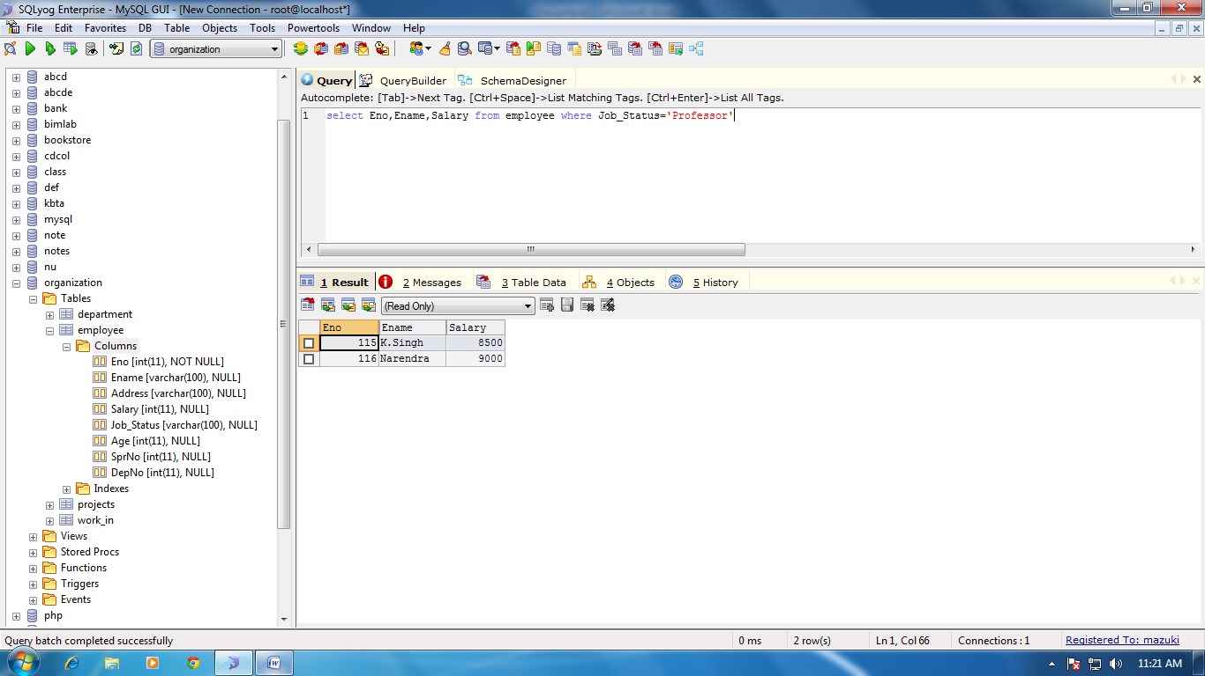

Select address from employee

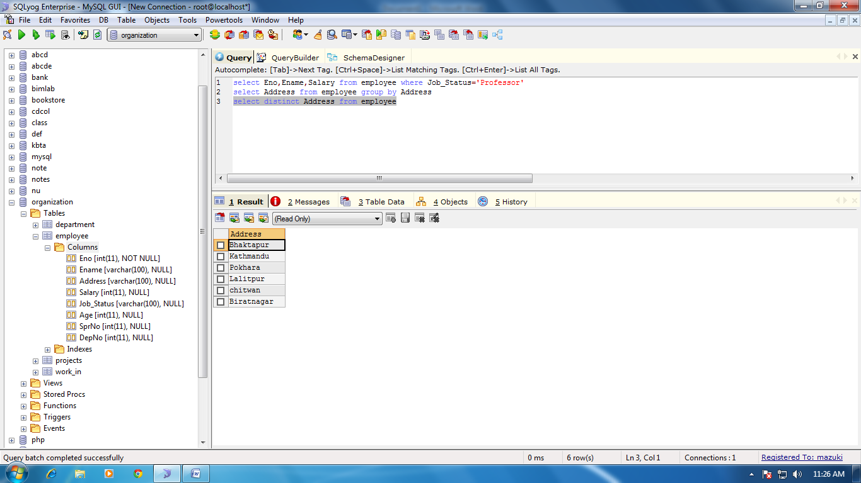

Find the eno,ename,salary of the employee whose department number 20 or job status researcher

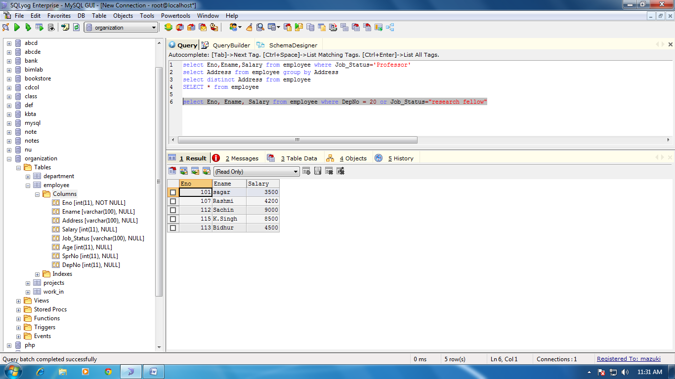

Find the eno, ename, age and salary from the employee where the age is between 24 and 28

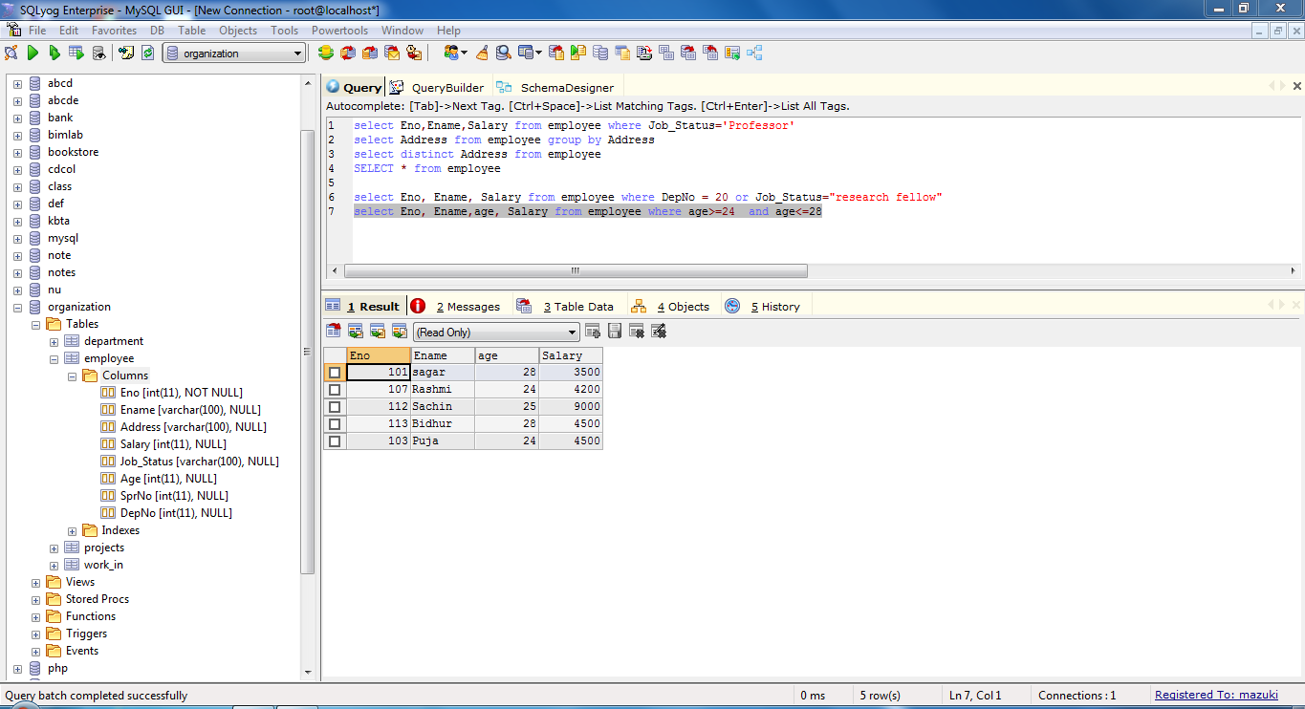

String Operation

BAC% : all strings that start with BAC

Abcd and abcabc both satisfy the condition

Find eno ename with starting letter sa

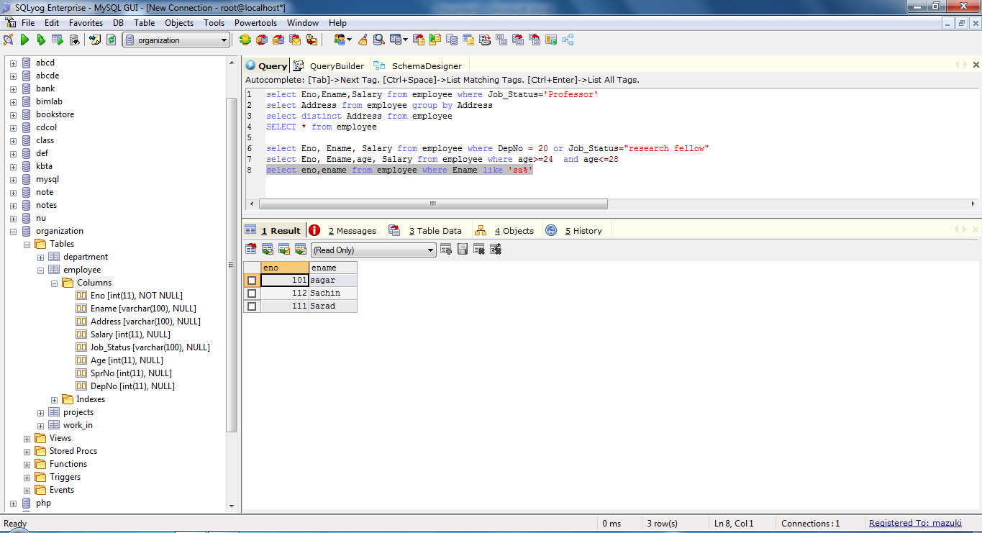

List all employee name with their project name

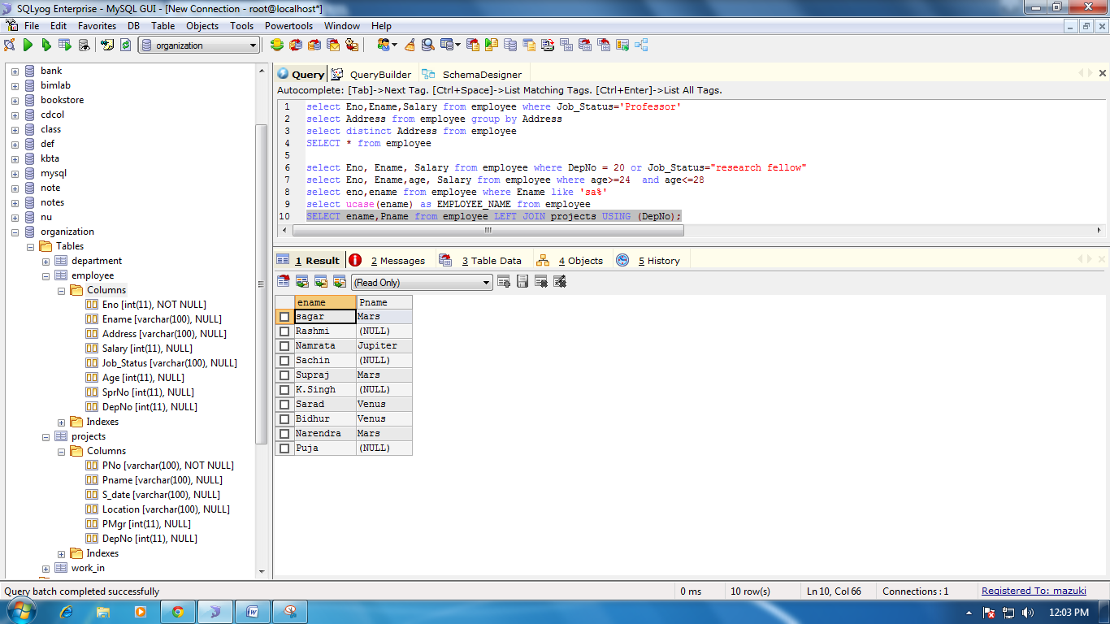

List all employee with their salary working with project earth and venus

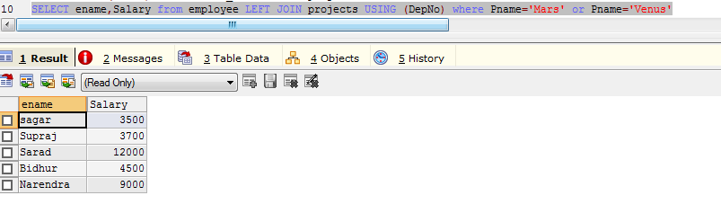

List name and salary of employee working in earth and venus



List name and salary of employee working in department which is located in pokhara

